12 Setting Up Particles

1. Create Font Node, enter, set Text = 5A;
2. Create Ends Node, set Close U = Unroll with New Points;
3. Create Sort Node, set Primitive Sort : By X;
4. Create Resample Node, set Length = 0.01;
5. Create Group by Range Node, Group Type = Points, Group Name = emit, Range Type = Start and Length, Start = ($FF - 5) * 5, Length = 10;
6. Create Pop Network, enter, delete wire_pops_into_here, create Gravity Force Node [popsolver, output];
7. Select source_first_input, set Attribute/Initial Velocity = Set initial velocity, Velocity = (0,0,20), Variance = (5,5,20), Birth/Life Expectancy = 0.6, Life Variance = 0.4, Source/Source Group = emit;
8. Create PopDrag Node[source_first_input, popsolver], set Air Resistance = 2;
9. Create GoundPlane and Merge Node, set Initial State PositionY = -1;

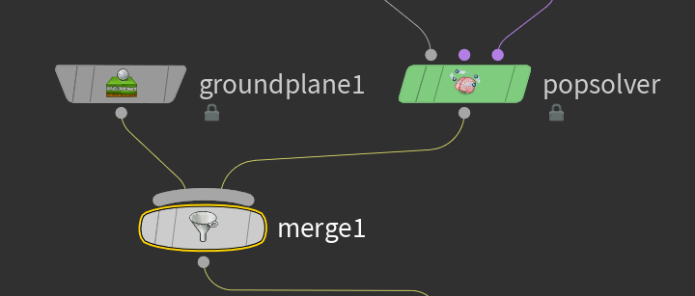

1. Up, set popnet, Object = popobject;
2. Enter, Create Merge Node;

